I-School Curricula:
How Wide? How Deep?

Dr. Richard A. Thompson
Telecommunications Program
School of Information Sciences
University of Pittsburgh

Personal Comment:
I recently stepped down after serving as Chair of Pitt’s Telecom Program for 16 years. The “fit” of a Telecom Program inside SIS at Pitt has been an ongoing discussion for most of my tenure. Now, as SIS tries to conform to the evolving definition of what an “I-School” is, the discussion of this “fit” has taken on even greater relevance. In my discussions with Dean Larsen in the last several years, I tried to cast the problem to be part of a larger one, which is: just how “wide” and “deep” should an I-School’s curriculum be? This talk/paper represents the state of this “larger” discussion, which Dean Larsen and I believe might be relevant to all I-Conference attendees.

Abstract:
The various academic disciplines are shown to occupy the space of human knowledge. One objective of this talk/paper is to propose how the I-School disciplines fit among the neighboring disciplines, and which disciplines are close or distant. The various classic disciplines are seen to distribute differently over a “Level of Abstraction” dimension (six levels are defined) in which Philosophy is mostly abstract and Engineeri-ng is mostly concrete. Then, this talk/paper discusses the I-disciplines’ abstraction-profile in significant detail. Curricular “depth” is defined as the number of layers of abstraction that should be included (I argue for five of the six).
It is observed that the I-disciplines have different discipline-neighbors at different levels of abstraction. For example, at the highest level of abstraction, the near neighbors are Philosophy (for Ethics) and Sociology (Maslow’s needs) and, at the lowest level of abstraction, the near neighbors are Computer Science and Electrical Engineering (imple-menting Information systems). In between, our near neighbors are Psychology (cogni-tion), Business, Law, Literature, Political Science, and others. The role of a “Profession-al School” is factored in. Then, the case is made that the I-School’s “sub-disciplines” (six are defined) may have different abstraction-profiles and different neighbors.
Curricular “width” is defined as how close our curricula should get to those of our near neighbors. Finally, “holes” are identified in the spaces between the I-disciplines and their neighbors. These holes represent significant areas of human knowledge, which are typically excluded from the academic disciplines at most universities. Professionals who have filled these holes have done it, perhaps poorly, by their own cleverness. This talk/ paper argues that the I-Schools should strive to fill those holes, but doing so may require even greater curricular width.

I-School Curricula: How Wide? How Deep?

Dr. Richard A. Thompson
Telecommunications Program
School of Information Sciences
University of Pittsburgh, 15260
US (412) 624-9423
thompson@sis.pitt.edu

ABSTRACT
The emerging discipline we call Information Science is shown to fit among its neighboring disciplines. After proposing any aca-demic discipline’s six levels of abstraction, and using them to define curricular “depth,” detailed investigation reveals that IS butts against different neighboring disciplines at different levels. Then, after proposing IS’ six sub-disciplines, they are shown not only to have different distributions across their levels of abstract-tion, but also to butt up against different neighboring disciplines. An I-School’s role as a “professional school” is factored into this discussion.
Curricular “width” is defined as how close a curriculum should get to its near neighbors. Then, “holes” are identified in the spaces between the I-disciplines and their neighbors. These holes represent areas of human knowledge, which are typically ex-cluded from all the academic disciplines at most universities. It is argued here that I-Schools should strive to fill those holes by expanding their curricular width.

Topic
Nature and scope of iSchools and iResearch
Keywords
Curriculum, Discipline, Information Science

INTRODUCTION
The paper is introduced on a personal note. I recently stepped down after serving for 16 years as the Chair of the Telecommu-nications Program at the University of Pittsburgh. One of my more important activities during these years has been to parti-cipate with the chairs of the nation’s other “Telecom” programs in defining Telecom as an academic discipline. Similar to the con-sortium of “I-Schools,” the nation’s “T-Programs” have tried to organized themselves, most recently under the banner of the International Telecommunications Education and Research Asso-ciation (ITERA). A corresponding paper [1], which asks the same questions of Telecom Programs that this paper asks of I-Schools, will be presented at the ITERA-08 Conference.

A related ongoing discussion during my tenure as Telecom Program Chair has been how my Telecom Program “fits” inside the School of Information Sciences at Pitt. Now, as SIS tries to conform itself to the evolving definition of what an “I-School” is, the discussion of this “fit” has taken on even greater relevance. In my discussions with Dean Larsen in the last several years, I have tried to cast the problem to be part of a larger one, which is: how “wide” and how “deep” should an I-School’s curriculum be? This paper represents the state of this “larger” discussion, which Dean Larsen and I believe might be relevant to all the I-Schools.
So, this paper proposes a two-dimensional universe for academic disciplines, attempts to place IS in this universe, and discusses the “fit” and the “holes.” The paper is not the “be-all and end-all” on this topic. Instead, it is intended to act as a framework that might guide the discussion which completes what this paper only begins. The paper asks more questions than it answers and, in fact, six questions are explicitly stated.

THE SPACE OF HUMAN KNOWLEDGE
Academic disciplines occupy a multi-dimensional space of human knowledge. This paper focuses on two of these dimensions, as shown in Figure 1 below.
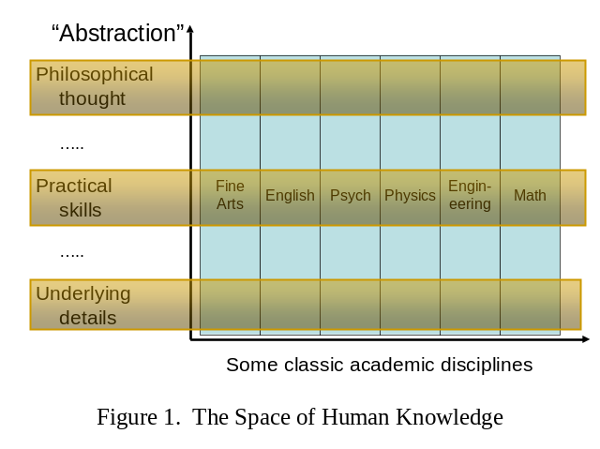

Two Dimensions

The Content Dimension, shown horizontally, is a spectrum that runs from the Fine Arts, through the Humanities and Social Sciences, to the Hard Sciences. The six columns represent only a few of the hundred or more recognized academic disciplines.

The Abstraction Dimension, shown vertically, is a spec-trum of the level of detail and theory that is typically investigated in each respective discipline. While Figure 1 shows only three levels of abstraction, this paper is based on these six:
- Rationale – a discipline’s broad justification.
- Framework – broad theory that establishes terminology in which to base generalized discussion and a structure for the discipline.
- Practice – the details that are needed by the people who will work in the field of endeavor that corresponds to the discipline.
- Optimization – detailed generalization and theory for the purpose of proving results, and determining various optimizations and best practices.
- Implementation – study of underlying infrastructure.
- Fundamentals – basic underlying principles.
For example, consider Education as an academic discipline. Its Rationale includes the discipline’s rather self-evident purpose and motivation and its Framework includes issues like Curriculum design (this paper). Its Practice includes issues like classroom skill, boardmanship, enunciation, etc. and its Optimization is the body of knowledge, typically covered in a course on “Ed Psych,” whose principles would presumably help us be better teachers and write better books. Education’s Implementation level includes topics like knowing how to use Power-Point. The Education Discipline has few underlying Fundamentals like we find in Phy-sics (Quantum Theory) or Biology (Genetics); one might be the elusive definition of learning.
The specification of these levels is certainly arguable; some might be combined and more might be defined. The discus-sion in this paper is based more on agreeing that academic disci-plines have levels like these than on the details of what the levels are. However, the next sub-section provides a little justification.
Question 1: Are these the appropriate levels of abstraction?
2.2 Sophistication and Theory
Two other concepts related to abstraction are sophistication and theory. Sophistication relates to the maturity of the student, while abstraction relates to the applicability of the material. As shown in Figure 2, they are not unrelated. Mature scholars appreciate
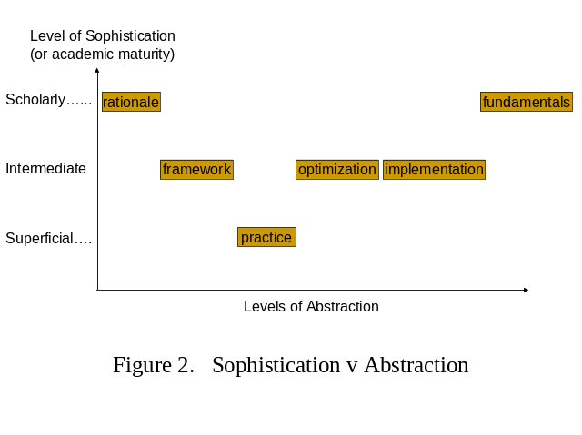
abstract issues like rationale and fundamentals, while immature students demand to know “what good is this?”
This paper separates theory into three layers, the even-numbered levels of abstraction in the list above: framework, optimization, and fundamentals. Level 2’s separation from Level 4 is based on an observation from Einstein in his 1933 essay, On the Method of Theoretical Physics:
“I want now to glance for a moment at the develop-ment of the theoretical method, and while doing so especially to observe the relation of pure theory to the totality of the data of experience. Here is the eternal antithesis of the two inseparable constituents of human knowledge, Experience and Reason, within the sphere of physics. Pure logical thinking can give us no knowledge whatsoever of the world of experience; all knowledge about reality begins with experience and terminates in it. Conclusions obtained by purely rational processes are, so far as Reality is concerned, entirely empty. But if experience is the beginning and end of all our knowledge about reality, what role is there left for reason in science? A complete system of theoretical physics consists of concepts, and basic laws to interrelate those concepts, and of consequences to be derived by logical deduction. Reason gives the structure to the system; the data of experience and their mutual relations are to correspond exactly to consequences in the theory.”
Paraphrasing Einstein, experience (Level 3) without underlying theory (Levels 2 and 4) is a disconnected set of obser-vations, and theory without observable verification gives no prac-tical knowledge. It is remarkable that a theoretician, as Einstein was, would assert that theory is subservient to practice; and that its role is to help us understand practice and it provide a frame-work for organizing our observations. However, since not all theory helps to frame our disciplines, this paper separates theory into two levels at least.

Placing the IS Discipline
The various classic disciplines are distributed differently over the levels in the Abstraction Dimension. Consider three examples: Philosophy is mostly Rationale and the discipline concentrates at the upper levels; Engineering is mostly Practice and the various Engineering disciplines concentrate in the central levels; Math-ematics, while shown as an upright rectangle in Figure 1, is the Foundation of the sciences and, as such, this discipline concen-trates in the lower levels.
In this paper, “depth” is a relative term, defined in the Abstraction Dimension. Depth is not the absolute location of a discipline’s center of gravity along this dimension but is, instead, the number of levels that receive significant coverage in a given discipline. By this definition, Philosophy, Engineering, and Mathematics are not very deep disciplines. Examples of deep disciplines are Music and most of the Social Sciences. Physics, which fully engages all six levels of abstraction, is perhaps the deepest of all the academic disciplines.
The objective of this paper is to propose how our new, emerging discipline fits into the space of human knowledge with the other, more established, academic disciplines. Our broadly defined Information Science discipline must be made to fit in horizontally and vertically. The IS discipline’s place in the total space of human knowledge has “width” and “depth” as illustrated in Figure 3. We determine our depth by identifying how our discipline distributes itself across the vertical “abstraction” axis and identifying our content in each level. We determine our width by specifying the location of IS’ center of gravity on the horizontal “discipline” axis, identifying which disciplines are our neighbors, and identifying how closely our discipline butts up against these neighbors.
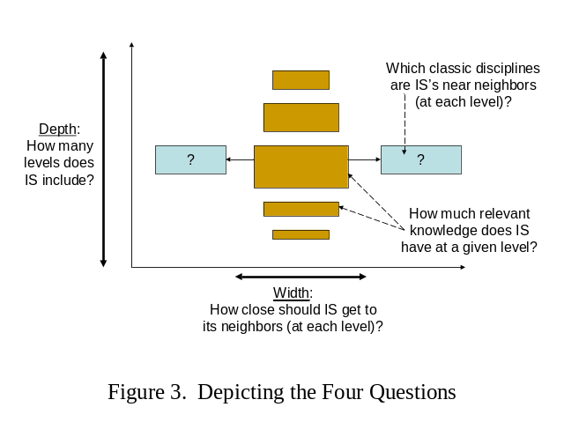Unfortunately, it’s not so simple. Perhaps, some day it will be, when our discipline becomes more mature. But, now, these tasks are complicated because (1) the disciplines we identify as our neighbors are different at different levels of abstraction and (2) the distribution across the “abstraction” dimension is different in our different sub-disciplines. Section 3 begins to discuss the issues, and begs for much more follow-up.

HOW DEEP AND HOW WIDE?
This section uses the following procedure:
- Identify IS’ significant sub-disciplines.
- Specify the IS discipline’s levels of abstraction and how much content (depicted as the level’s thickness) we have in each level.
- Identify the neighboring disciplines for each level and recommend the width of each level.

The IS Sub-Disciplines(?)
Like everything else in this paper, this topic requires a lot of discussion and the proposal here may even be a little contentious. But, for our purposes, this paper assumes that Information Sci-ence is a “super-discipline” (see Section 4.2), comprised of the following six “sub-disciplines:”
- Librarianship
- Information Organization
- Information Management
- Information Systems
- Telecommunications
- Information Security
We make no attempt here to define or differentiate these; that is an important but separable, discussion. The point here is not that we agree that Information Science has these exact six sub-disciplines, but simply that we acknowledge that IS has several sub-disciplines, and they are something like these six.
Question 2: Is this the complete list of IS’ sub-disciplines?
Figure 4’s vertical axis shows the six proposed levels of abstraction. However, Figure 4’s horizontal axis is a microscopic view of the disciplines of human knowledge, illustrating the six sub-disciplines of our Information Science super-discipline. The figure serves to frame the discussion that follows. We will not discuss all 36 cells now; but eventually we must.
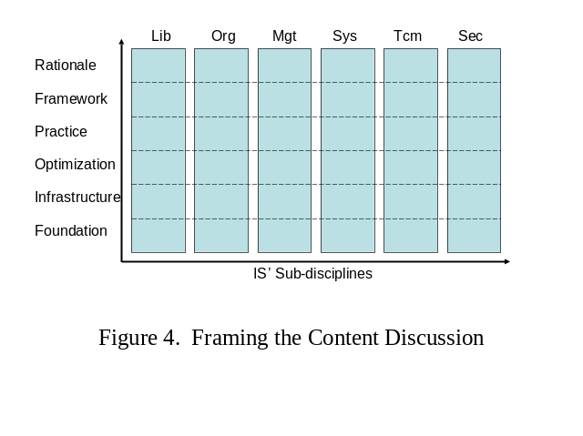3.2 How Deep?
The previous section described and defined six levels of abstract-tion. So, first, we examine how the IS super-discipline might dis-tribute across these six levels. While we’re at it, let’s also discuss how much relevant knowledge (as depicted by the thickness of each horizontal band in Figure 3) we have at each level.
Rationale – Our Librarianship students typically understand our justification better than those in IS’ other sub-disciplines. We don’t have very much here, but all of our students should understand enough Ethics to resonate with the “Digital Divide” and they should understand how information fits into Maslow’s hierarchy of human needs.
Framework – Much of the framework that organizes our discipline is found in a course commonly called “Information Retrieval.” We need to develop this framework better, and ensure it’s exposure to students in all our sub-disciplines, but we have a good start.
Practice – Each of the sub-disciplines described above focuses on the practical aspects of its corresponding profession. Since the I-Schools identify themselves as “Professional Schools,” this is appropriate and it is our strength. IS’ various sub-disciplines are appropriately separated in this level.
Optimization – Our discipline has little to offer at this level, but it’s included in this list because Information Scientists must develop this if we are going to be taken seriously by the other disciplines. While we can optimize some things in Telecom, the other sub-disciplines must develop theory by which to compare two Information Systems and determine which one is better (whatever that means); or IS will forever be denigrated by our sister disciplines.
Implementation – Our Information Systems are built out of programs and electronic hardware. We have little to offer that is exclusively our own; but that’s changing as the WWW, HTML, hypertext, and other implementation details are perceived more-and-more as the purview of IS; and not CS. Our various sub-disciplines cover this material differently, if at all, depending on entrance requirements and students’ skills.
Fundamentals – Our only true fundamental concept is Shannon’s definition of Information. But, very few of us teach it and few of our students have the math skills to understand it, nor the sophis-tication to appreciate it. So, the amount of IS at this lowest level is slim-to-none.
Question 3: Are there other contributions in Levels 1, 2, 4, 5, and 6?
Since most of IS’ content lies in Layers 2 and 3, the IS discipline is quite thin and will remain so unless we develop levels 1, 4, and 5 and try to teach level 6.

3.3 How Wide?
Now, let’s examine where the various levels of our various sub-disciplines fit along the horizontal axis of human knowledge. We’ll do this do identifying the neighboring disciplines at each level. This discussion is very incomplete; it presents only a small sample from the 36 cells defined in Figure 4.
Rationale – Our neighboring disciplines are Philosophy (when we discuss Ethics) and Sociology (when we discuss Maslow’s needs). What we typically present is mostly borrowed from these neighbors, but we should develop it further and we should con-sider presenting this material to students in all our sub-disciplines.
Framework – Illustrating the diversity of our discipline, this level’s many neighbors include: Psychology (for Cognition), Business (for managing information organizations and projects and for understanding applications in all organizations), Law and Political Science (for policy, intellectual property law, and e-government), Computer Science (for databases and data struc-tures), and Literature (important in Librarianship).
Practice – While our Information Systems sub-discipline used to butt up against Business’ MIS sub-discipline and our Information Systems and Information Security sub-disciplines butt up against Computer Science, we have succeeded recently at carving out more of our own space at this level.
Optimization – Most of what we do at this level is borrowed from Computer Science; although Telecom also borrows heavily from Electrical Engineering for optimizable concepts like bandwidth and signal-to-noise ratio. Information Science is sadly lacking at this level and, as stated earlier, Information Scientists must deve-lop this level if we want to be taken seriously.
Implementation – The neighboring disciplines are Computer Science (for implementing programs) and Electrical Engineering (for implementing Information systems).
Fundamentals –Shannon’s definition of Information is borrowed from Electrical Engineering, but we should cast it in a more gene-ral way. Since it is our only fundamental, we should consider teaching it in all our sub-disciplines, even if it means sufficiently developing our students’ math skills so they can understand it.
While the discussion above identifies IS’ many neighboring disciplines, it does not discuss the boundary between IS and its neighbors. That discussion, while it logically follows directly, is so relevant to IS curriculum design that this paper separates it into a separate, and concluding, Section 4.
Question 4: Not so much a question but, we must fill in details from all 36 cells in Figure 4.
3.4 Variations
Figure 5 below summarizes much of this section’s discussion. Again, it’s not meant to be the final word on this topic, but it attempts to illustrate the profiles of two of our sub-disciplines and how we might structure the IS super-discipline if we offered it as three different academic degrees.
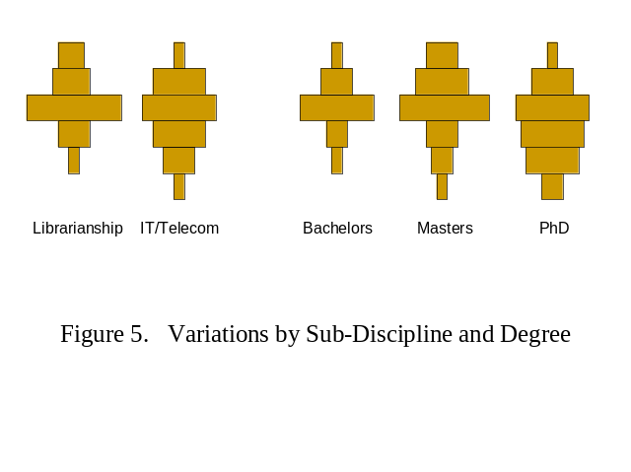

WHERE DO WE GO FROM HERE?

Filling the Holes
Having described our near neighbors and the body of knowledge we have in common with them, let’s discuss now how closely we should butt up against these neighbors. At each level of abstrac-tion, we observe gaps or “holes” in the spaces between the I-disci-pline and its neighbors. These holes represent areas of human knowledge that are typically excluded from the academic disci-plines at most universities. Many professionals, who graduated from our programs, have filled these holes themselves, perhaps poorly, by their own cleverness. Perhaps we could do a better job of preparing them for their professions by filling these holes for them while they are our students.
For example, those Telecom Program Chairs, who are trying to unify the nation’s Telecom curriculum, struggle with what we call the Physical Layer. How well should a Telecom Professional understand Physical-Layer concepts like bandwidth, noise, filters, reflections, attenuation, and other forms of signal distortion? How well should they understand how signals propa-gate through wires, fibers, and free-space?
Many of us reside in universities that also have Elec-trical Engineering departments, where this material is taught, but in a general way that also applies to electrical circuits, power systems, control systems, and other sub-disciplines of EE. Fur-thermore, when the EE’s teach this material, they do it in a math-ematical presentation that many Telecom students struggle with (in fact, the EETs split off from the EEs over this issue). Telecom students don’t need that generality or mathematical presentation and EE students don’t need the specific details in the Telecom application? So, there is no perfect course, the “hole” in Figure 6, unless we in Telecom teach it ourselves.
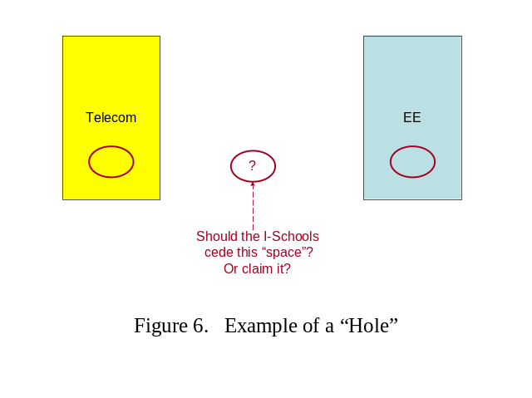
There are many other examples; only a few are listed below:
- Material on Information Ethics and on the human need for information could be part of the IS super-discipline; not left for one of its sub-disciplines and not left for the Philosophy or Sociology disciplines to offer.
- Many universities don’t offer a course on human cogni-tion, in IS nor in Psych. Our students need to know how the “human component” performs as part of an Information System. And, they would be better served by an IS approach to cognition.
- While the Business Schools at our respective universities might offer courses on MIS, Organizational Behavior (including the impact of technology on organizations) and Project Management, these are typically offered too generally. Our students need to understand the impact of information, and not all tech-nologies, on organizations and they need to learn how to manage projects in their sub-disciplines.
- We have similar issues with the Law School and Political Science Department for course material on policy, intellectual property law, and e-government.
- Our problem with the Computer Science Department is even worse because the typical CS course on databases and data structures usually entails far more program-ming assignments than our students need.
- This list isn’t complete without saying one more time that Information Scientists must develop a theory that supports Information Systems optimization. And, we should consider teaching Shannon’s definition of Iinformation in all our sub-disciplines, even if it means sufficiently developing our students’ math skills so they can understand it.
This paper argues that the I-Schools should strive to fill these holes. But, there are two (at least) problems:
- Most IS faculty are very eclectic, but offering this list of courses will require even greater diversity and breadth.
- We get into the very difficult area of university econ-omics and the pressure most of our universities are putting on us to “joint-list” more courses.

Question 5: Again not really a question, but we should compile a more complete list of the other holes we need to consider filling.

Defining the Super-Discipline
Our overall super-discipline should be greater than the inter-section of the academic content covered by these six sub-disci-plines, but small than their union. It should be some reasonable selection of the best parts from these six sub-disciplines. Then each of these sub-disciplines would be a specialization within this super-discipline.
When we look at the other schools and colleges at our respecttive universities, we see several models for how super-disciplines and sub-disciplines inter-operate. We need to consider which of these models is appropriate for us.
- In Arts and Sciences and in Engineering, about half the courses any student takes are common across all depart-ments and about half are specific to a department.
- In most of the constituent departments, about three-fourths of what a student takes is common, and students may specialize in their final one or two semesters.
- In other schools, like Business, the curriculum is more isolated from the other disciplines. They may object to this characterization but, for example, while Math, Science, and Engineering students all take the same Calculus course, Business students have their own.
The I-Schools can adopt one of these models. This isn’t much of an issue for an I-School that offers only one or two of the six identified sub-disciplines. But, if an I-School claims to cover the entire spectrum, or wishes to evolve in that direction, it might organize its curriculum as a common super-discipline with specia-lizations, or as separate sub-disciplines with a small common core, or as something in between.
In SIS at Pitt, we offer these six sub-disciplines, but they have been “silo-ed” for too long. We are developing a com-mon introductory course, to be offered to all students next Fall Semester, and we are considering a common capstone course.
Question 6: What is “the right architecture” for the Information Science super-discipline?

REFERENCES
- Thompson, R. 2008. The Telecommunications Curriculum – How Wide? How Deep? In the Proceedings of the ITERA-08 Conference (Louisville, KY, March 27-29, 2008). To be published. http://www.itera.org.
- Einstein, A. 1933. On the Method of Theoretical Physics. From Madden, E. H. (ed.). 1960. The Structure of Scientific Thought. Houghton-Miflin, 1960 (essay originally published by Oxford University Press in 1933).

